# Nosetest Practical Guide

Before using any of these nose command, make sure:

* Install nose package simply by running this command:

|  |
| --- |
| pip install nose |

(If needed, the details of installation process can be seen here: <https://nose.readthedocs.org/en/latest/> )

* You have set the environment variable so the nose command can be called from any directory on your local machine
* You are in the directory you will be working on before doing any of these command

**#Nose commands**

1. Running single test case

|  |
| --- |
| nosetests testcase.py |

1. All test case (in a folder)

* Must go to directory first

|  |
| --- |
| nosetests |

1. Running all test case with xunit output and write to file

|  |
| --- |
| nosetests **--with-xunit --xunit-file**=logs/testresult2.xml |

1. Running selected test case with xunit output and write to file

|  |
| --- |
| nosetests **--tests=**testcase1.py,testcase2.py --with-xunit --xunit-file=logs/testresult2.xml |

* Warning: No whitespace allowed between test case file.

1. dASd

**#Nose commands on Jenkins**

Nose commands can also be used in Jenkins. Here is the example of the shell execution in Jenkins:

|  |
| --- |
| export PYTHONPATH=${PYTHONPATH}:/var/lib/jenkins/jobs/ReportingLab/workspace/  cd /var/lib/jenkins/jobs/ReportingLab/workspace/test_case/desktop_v3/nosetest  **/nosetests-3.4** --tests=test_deposit.py,test_inbox_talk.py --with-xunit --xunit-file=logs/lab_result.xml |

# XUnit Lab Result

1. **Two files with the same xunit filename pattern**

Purpose: To see the possibility of using timestamp in result name.

Steps:

* Set the xunit file pattern to lab_*.xml (get all result start with lab_)
* Run test_deposit.py with result name lab_deposit.xml
* Run again test_deposit.py with result name lab_deposit2.xml
* See the test result

Result: **Failed**.

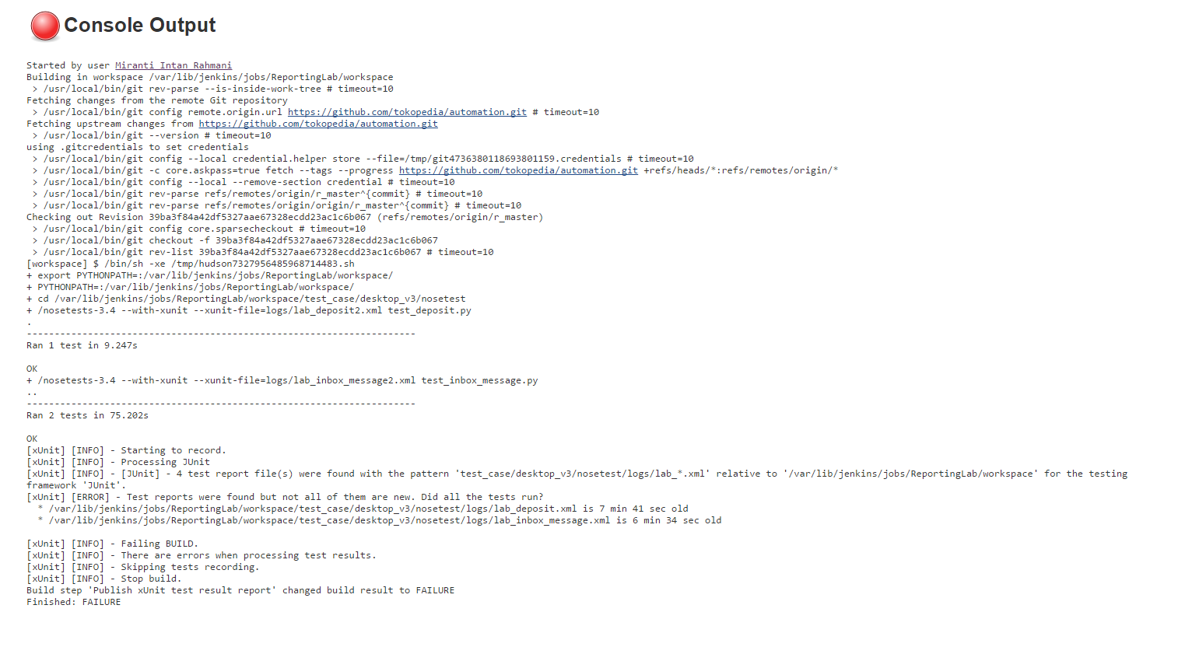

1. **Two files with two different result name, but with the same xunit filename pattern**

Purpose: To see if the chart can be generated from many test result within the same pattern

Steps:

* Set the xunit file pattern to lab_*.xml (get all result start with lab_)
* Run these scripts:

/nosetests-3.4 --with-xunit --xunit-file=logs/lab_deposit.xml test_deposit.py

/nosetests-3.4 --with-xunit --xunit-file=logs/lab_inbox_message.xml test_inbox_message.py

* See the result

Result: **Success**

1. **Delete test case**

Purpose: to see how the chart behaves

Steps:

* Run several test cases (e.g. 2 test cases out of 10)

Result: Success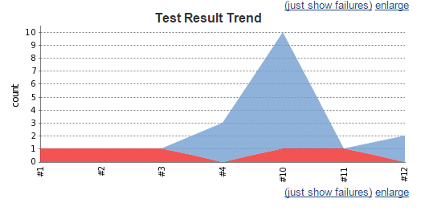

Common problems with XUnit plugins:

* False report 🡪 No failed test case but the build is considered ‘Failed’.
* Option stop and set the build to 'failed' status if there are errors when processing a result file 🡪 if unchecked, and there is failure in report processing, the build status is still failed.
* Do not support file versioning 🡪 if more than 2 files **under the same pattern** and **the same contents** are found and read by the plugins, it causes an error.